Full Name: **Janssen T. Pedrola**

Nickname: **Jans**

Age: **20 years old**

Birthdate: **January 26, 2002**

Senior High School Graduated From? City the High School is located at: **UBIX Institute of Technology Inc. located at Muntinlupa City**

Course: **BS Computer Science with specialization in Software Systems**

Scholarship? Yes / No If yes, %? type? **SM Foundation Scholarship, 100%**

Transferee / Second Course? **Not a transferee and this is my first course**

Did you choose this course? Yes / No: **Yes**

Why Yes? **Because this is one of the courses that SM requires for their scholars and when I searched about those courses beforehand, the opportunity in this course is bright and I’m amazed by how technology improved the human life.**

If No, what course would you choose?

I.T. Experience: Programming / Gaming / Others: **I have prior IT experience from being user of varieties of gadgets and applications, learnings about hardware and software infrastructures/ architectures, UI and UX experience, Coding, Data Science, and other learnings from my previous subjects since it’s my 3rd year now in this course.**

Hobbies / Interests / libangan: **I have interests in personal growth in every aspect of life.**

Goals in life / pangarap sa buhay: **To grow and become better person.**

What do you expect to learn from this course (Systems Analysis & Detailed Design for CS-SS )? **To learn how to make an application that address the pain points of the users and be able to learn more technology that I can integrate in the system to equip it with better components and enhance my skills more.**

What do you want to learn to help you in your chosen Major?

**Advice from an experienced mentor on how to make a certain thing. Like what technology and how can I integrate it in the system that we will be developing.**

Any other interesting aspects of your life that you would like to share:

**I think I’m getting better at understanding life now more than before. I am now more open to learning and have realized that being able to accept that you fail or made a mistake even makes you a stronger and better person.**

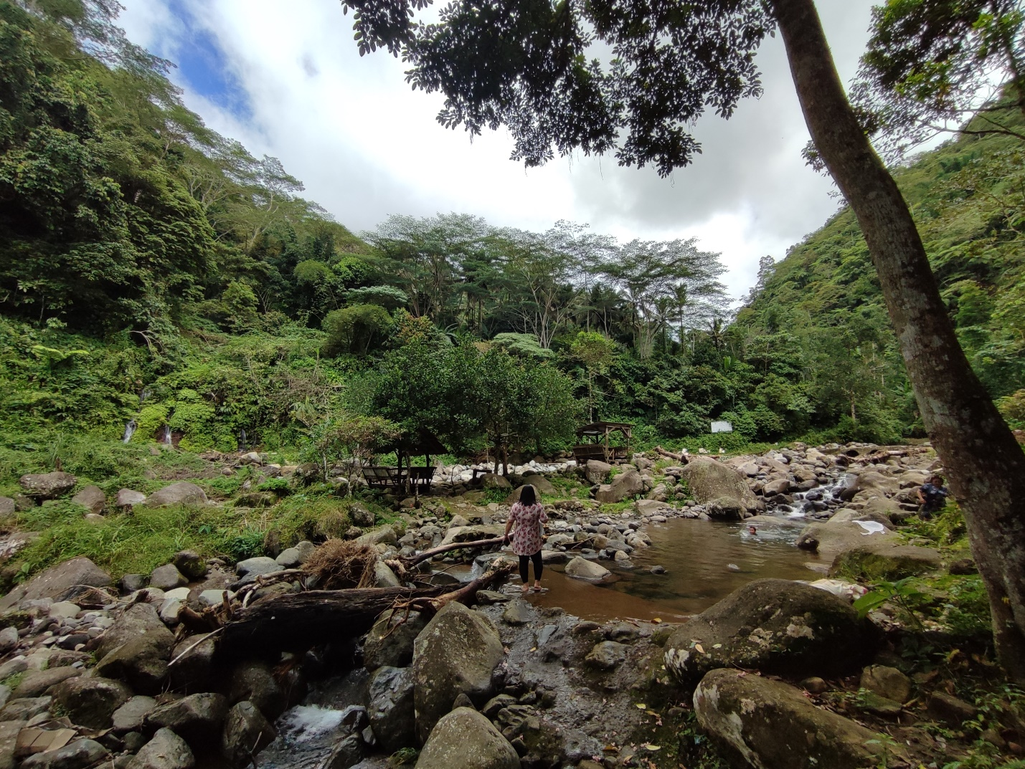Add one or more pictures about yourself and your interests that you would like to share for your introduction.

**As I mentioned above that I am interested more in personal growth, I would like to use this photo to emphasize how I am gradually trying to achieve personal growth by learning from the behavior of the water. This is not originally from me but from one of the TedxTalks video that I watched. Water adapts to the environment where it was and continues to flow while being humble**